**REQUIREMENTS NOT MET**

N/A

**PROBLEMS ENCOUNTERED**

I didn’t really come across any problems. I just took some time to fully understand some concepts and actually code them well. Also, I feel like I took around 50 screenshots because my monitor is huge, so the screenshots look really small on the document. So, in order to get them to match the rule/policies I had to keep retaking them.

**FUTURE WORK/APPLICATIONS**

Being able to work with I/O ports is super helpful for anything. This gives your application a simple interface that is easy to debug and visually see what is happening with data. Also, working with timer counters was interesting and I can easily see how we will use them throughout the rest of this class. Being able to manipulate and use our clock in different ways just makes our programs quicker, easier, and more understandable.

**PRE-LAB EXERCISES**

1. Which configuration register allows the utilization of an I/O port pin configured as an input? Which configuration registers allow the utilization of an I/O port pin configured as an output?

IN for input OUT for output

1. What is the purpose of the SET/CLR/TGL variants of the DIR and OUT registers?

SET/CLR/TGL modify individual pins/bits corresponding to the DIR register.

1. Which I/O ports are utilized for the DIP switches and LEDs on the OOTB Switch & LED Backpack?

PortA, PortC, and PortF

1. Are the LEDs on the OOTB Switch & LED Backpack active-high, or active-low? Draw a schematic diagram for a single LED circuit with the same activation level used on the backpack, as well as one with the opposite activation level. Also, draw a schematic diagram for a single-pole, single-throw (SPST) switch circuit, using the same pull-up or pull-down resistor condition utilized on the backpack, as well as another switch circuit using the opposite configuration.

The LEDs are active-low.

(put drawings here)

1. Would it be possible to interface the OOTB µPAD with an external input device consisting of 24 inputs? If so, describe how many I/O ports would be necessary. If not, explain why.

Yes, you could have 24 inputs. You would need 3 I/O ports.

1. Assuming a system clock frequency of 2 MHz, a prescaler value of 256, and a desired period of 50 ms, calculate a theoretically-corresponding timer/counter period value two separate times: once using a form of dimensional analysis, providing explanation(s) when appropriate, and another time using the general formula provided within The Most Common Use Case for Timer/Counters.

Dimensional analysis: $\frac{2*{10}^{6} SCtick}{1 sec}* \frac{1 TCtick}{256 SCtick}* \frac{0.5 sec}{50 ms}=\frac{3906.25 TCtick}{50 ms}$

General formula: $PRE= 0.5\left(\frac{2*{10}^{6}}{256}\right)=3906.25$

1. Assuming a system clock frequency of 2 MHz, is a period of two seconds achievable when using a 16-bit timer/counter prescaler value of one? If not, determine if there exists any prescaler value that allows for this period under the assumed circumstances, and if there does, list such a value.

No, you cannot achieve this with a prescaler value of one.

$$2^{16}-1=65,535$$

$$2 sec* \frac{2*{10}^{6} SCtick}{1 sec}* \frac{1 TCtick}{1 SCtick}= 4,000,000$$

$$4,000,000>65,535$$

We can only count to 65,546 with a prescaler value of one, but we would need to count to 4,000,000. If we divide, we can find the least prescaler value that would work for us.

$$\frac{4,000,000}{65,535}=61.036$$

We need to round up to the nearest whole number, so we round the prescalar up to 62.

$$2 sec* \frac{2*{10}^{6} SCtick}{1 sec}* \frac{1 TCtick}{62 SCtick}= 64516.12903$$

$$64,516.12903<65,535$$

So, you need at least a prescalar value of 62 to reach a period of 2 seconds. The closest prescalar clock we could use is 64.

1. What is the maximum time value (to the nearest millisecond) representable by a timer/counter, if the relevant system clock frequency is 2 MHz? What about for a system clock frequency of 32.768 kHz?

$$x sec=65,536*\frac{1}{2*{10}^{6}}$$

$$x sec=0.032768 sec$$

$x ms=3ms$

$$x sec=65,536*\frac{1}{32.768*{10}^{3}}$$

$$x sec=2 sec$$

$$x ms=2000ms$$

1. 3.2 with a prescalar of 2

/*

* lab2_3.asm

*

* Created: 6/7/2020 4:34:29 PM

* Author: Koby Miller

*/

.include "ATxmega128A1Udef.inc"

.equ F_CPU = 2000000

.equ CLK_PRE_TWO = 2

.equ FRAME_PER_A = 1/20 ;50ms

.equ FRAME_PER_RECIP_A = 20

.ORG 0x0000

rjmp MAIN

.ORG 0x0100

MAIN:

; initialize stack, start at 0x3FFF

ldi r16, 0xFF

sts CPU_SPL, r16

ldi r16, 0x3F

sts CPU_SPH, r16

; initialize ports for switches/LEDs

ldi r16, 0xFF

sts PORTC_OUT, r16 ; this sets all LEDs

sts PORTC_DIR, r16 ; sets direction as outputs

ldi r16, 0x00

sts PORTA_DIR, r16 ; sets direction of switches as inputs

rcall TCC0_INIT

LOOP:

lds r16, TCC0_INTFLAGS

sbrs r16, 0 ; if 0, skip the next instruction

rjmp LOOP

ldi r16, 0xFF ; this is used to toggle every light

sts PORTC_OUTTGL, r16

; clear OVFIF

ldi r16, TC0_OVFIF_bm

sts TCC0_INTFLAGS, r16

rjmp LOOP

DONE:

rjmp DONE

TCC0_INIT:

push r16

clr r16

sts TCC0_CNT, r16

sts(TCC0_CNT+1), r16

;set TCC0 period register

;TCC0_PER = (fclk/prescalar) * (duration in seconds)

; 2MH/2 0.05

;when you use the reciprocal, you divide by the duration

;assembler can't do decimals

ldi r16, low((F_CPU/CLK_PRE_TWO)/FRAME_PER_RECIP_A)

sts TCC0_PER, r16 ; 2,000,000/2 /20 = 1,000,000/20 = 50000

ldi r16, high((F_CPU/CLK_PRE_TWO)/FRAME_PER_RECIP_A)

sts (TCC0_PER + 1), r16

;starts timer counter with prescaler of 2

ldi r16, TC_CLKSEL_DIV2_gc

sts TCC0_CTRLA, r16

pop r16

ret

1. Assembly program to keep track of elapsing minutes. Minutes saved in r18

.include "ATxmega128A1Udef.inc"

.equ F_CPU = 2000000

.equ CLK_PRE = 64

.equ FRAME_PER_A = 1/1

.equ FRAME_PER_RECIP_A = 1

.ORG 0x0000

rjmp MAIN

.ORG 0x0100

MAIN:

; initialize stack, start at 0x3FFF

ldi r16, 0xFF

sts CPU_SPL, r16

ldi r16, 0x3F

sts CPU_SPH, r16

; initialize ports for switches/LEDs

ldi r16, 0xFF

sts PORTC_OUT, r16 ; this sets all LEDs

sts PORTC_DIR, r16 ; sets direction as outputs

ldi r16, 0x00

sts PORTA_DIR, r16 ; sets direction of switches as inputs

rcall TCC0_INIT

ldi r17, 60 ; We will count the seconds here (count down)

ldi r18, 0 ; We will count the minutes here

LOOP:

lds r16, TCC0_INTFLAGS

sbrs r16, 0 ; if 0, skip the next instruction

rjmp LOOP

ldi r16, 0xFF ; this is used to toggle every light

sts PORTC_OUTTGL, r16

; clear OVFIF

ldi r16, TC0_OVFIF_bm

sts TCC0_INTFLAGS, r16

dec r17

sbrs r17, 0 ; if 0, skip the next instruction

rjmp LOOP

ldi r17, 60 ; if here, reset second count and increase minute count

inc r18

rjmp LOOP

DONE:

rjmp DONE

TCC0_INIT:

push r16

clr r16

sts TCC0_CNT, r16

sts(TCC0_CNT+1), r16

;set TCC0 period register

;TCC0_PER = (fclk/prescalar) * (duration in seconds)

; 2MH/64 1

;when you use the reciprocal, you divide by the duration

;assembler can't do decimals

ldi r16, low((F_CPU/CLK_PRE)/FRAME_PER_RECIP_A)

sts TCC0_PER, r16 ; 2,000,000/64 /1 = 31250

ldi r16, high((F_CPU/CLK_PRE)/FRAME_PER_RECIP_A)

sts (TCC0_PER + 1), r16

;starts timer counter with prescaler of 64

ldi r16, TC_CLKSEL_DIV64_gc

sts TCC0_CTRLA, r16

pop r16

ret

1. It isn’t necessary to debounce those two switches because after the switch is initially pressed, there is no other action that can be done because of that switch. For example, when you press the switch to go into “PLAY” mode, it doesn’t matter how long or how many times you press the “PLAY” button. You need to push a different switch in order to change modes. So, the bouncing of the switch would not alter the logic after the first press. Unlike the logic to save a frame. After a frame is saved, the logic can stay in the same “area” and end up saving extra frames.
2. A scenario in which lab2_4.asm could experience unintended behavior due to tactile switch bouncing would be if the program used the “PLAY” button to also pause the LEDs. So say you start the animation with the “PLAY” button, instead of only being able to go back to “EDIT” mode, you could program it to “PAUSE” if you hit the same switch as the “PLAY” button. This would require you to debounce that switch.  
   If we are not altering the program to find unintended behavior, than the only thing I can think of is if you tried to go back and forth between “PLAY” and “EDIT” really fast, but nothing would really happen.

**PSEUDOCODE/FLOWCHARTS**

Part 1 – 3 mainly had the same sort of simple flow:  
Initialize stack -> initialize I/O ports -> (Initialize counter for part 3) -> toggle/turn on LED -> count for a certain amount of time -> repeat.

Part 4 Flowchart:

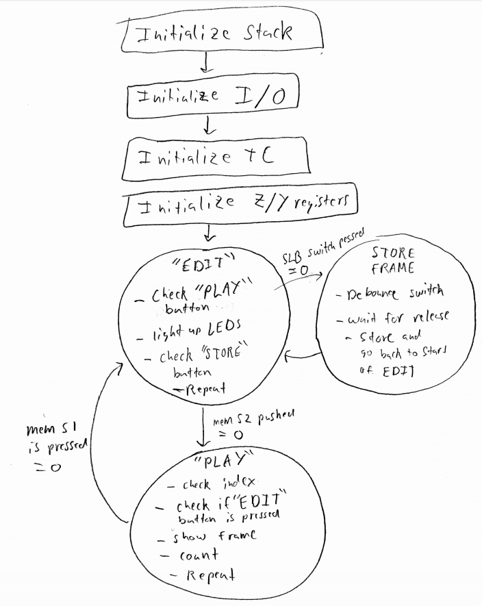

**PROGRAM CODE**

Starting from MAIN

MAIN:

; initialize the stack pointer

ldi r16, 0xFF

sts CPU_SPL, r16

ldi r16, 0x3F

sts CPU_SPH, r16

; initialize relevant I/O modules (switches and LEDs)

rcall IO_INIT

; initialize (but do not start) the relevant timer/counter module(s)

rcall TC_INIT

; Initialize the X and Y indices to point to the beginning of the

; animation table. (Although one pointer could be used to both

; store frames and playback the current animation, it is simpler

; to utilize a separate index for each of these operations.)

; Note: recognize that the animation table is in DATA memory

;Y init. Using to store

ldi YL, BYTE3(ANIMATION)

out CPU_RAMPY, YL

ldi YH, BYTE2(ANIMATION)

ldi YL, BYTE1(ANIMATION)

;Z init. Using to playback

ldi ZL, BYTE3(ANIMATION)

out CPU_RAMPZ, ZL

ldi ZH, BYTE2(ANIMATION)

ldi ZL, BYTE1(ANIMATION)

; begin main program loop

; "EDIT" mode

EDIT:

; Check if it is intended that "PLAY" mode be started, i.e.,

; determine if the relevant switch has been pressed.

;For some reason, bit 1 is for switch S2 even though skematic has it as bit 0

lds r16, PORTE_IN ;read input of memory base tactical switch S2

sbrs r16, 1 ;skip next instruction if bit = 1 meaning not pressed (button not pressed = pulled high)

rjmp PLAY

; If it is determined that relevant switch was pressed,

; go to "PLAY" mode.

; Otherwise, if the "PLAY" mode switch was not pressed,

; update display LEDs with the voltage values from relevant DIP switches

; and check if it is intended that a frame be stored in the animation

; (determine if this relevant switch has been pressed).

lds r16, PORTA_IN

sts PORTC_OUT, r16

; If the "STORE_FRAME" switch was not pressed,

; branch back to "EDIT".

lds r16, PORTF_IN

sbrc r16, 2 ;skip next instruction if bit = 0 meaning it is pressed

rjmp EDIT

; Otherwise, if it was determined that relevant switch was pressed,

; perform debouncing process, e.g., start relevant timer/counter

; and wait for it to overflow. (Write to CTRLA and loop until

; the OVFIF flag within INTFLAGS is set.)

;starts timer counter with prescaler of 256

ldi r16, TC_CLKSEL_DIV256_gc

sts TCC0_CTRLA, r16

;I measured around a 10ms debounce rate for the switch. To be safe and to reuse code

;I can use the same TC that counts the frames and just count 50ms

LOOP:

lds r16, TCC0_INTFLAGS

sbrs r16, 0 ; if 1, skip the next instruction

rjmp LOOP

; After relevant timer/counter has overflowed (i.e., after

; the relevant debounce period), disable this timer/counter,

; clear the relevant timer/counter OVFIF flag,

; and then read switch value again to verify that it was

; actually pressed. If so, perform intended functionality, and

; otherwise, do not; however, in both cases, wait for switch to

; be released before jumping back to "EDIT".

ldi r16, TC_CLKSEL_OFF_gc ;Turn it off

sts TCC0_CTRLA, r16

ldi r16, TC0_OVFIF_bm ;clear OVFIF

sts TCC0_INTFLAGS, r16

lds r16, PORTF_IN ;read press again

sbrc r16, 2 ;skip next instruction if bit = 0 meaning pressed

rjmp EDIT

; Wait for the "STORE FRAME" switch to be released

; before jumping to "EDIT".

STORE_FRAME_SWITCH_RELEASE_WAIT_LOOP:

lds r16, PORTF_IN ;read until not pressed

sbrs r16, 2 ;skip next instruction if bit = 1, not pressed

rjmp STORE_FRAME_SWITCH_RELEASE_WAIT_LOOP

;If here, now store

lds r16, PORTA_IN

st Y+, r16

rjmp EDIT

; "PLAY" mode

PLAY:

; Reload the relevant index to the first memory location

; within the animation table to play animation from first frame.

ldi ZL, BYTE3(ANIMATION)

out CPU_RAMPZ, ZL

ldi ZH, BYTE2(ANIMATION)

ldi ZL, BYTE1(ANIMATION)

PLAY_LOOP:

; Check if it is intended that "EDIT" mode be started

; i.e., check if the relevant switch has been pressed.

;For some reason, bit 0 is for switch S2 even though skematic has it as bit 1

lds r16, PORTE_IN ;read input of memory base tactical switch S1

sbrs r16, 0 ;skip next instruction if bit = 1 meaning not pressed

rjmp EDIT

; If it is determined that relevant switch was pressed,

; go to "EDIT" mode.

; Otherwise, if the "EDIT" mode switch was not pressed,

; determine if index used to load frames has the same

; address as the index used to store frames, i.e., if the end

; of the animation has been reached during playback.

; (Placing this check here will allow animations of all sizes,

; including zero, to playback properly.)

; To efficiently determine if these index values are equal,

; a combination of the "CP" and "CPC" instructions is recommended.

cp ZL,YL

brne DIFFERENT_ADDRESS

cp ZH,YH

brne DIFFERENT_ADDRESS

;cp CPU_RAMPZ, CPU_RAMPY

;brne DIFFERENT_ADDRESS

;If here, they are at the same address

rjmp PLAY

; If index values are equal, branch back to "PLAY" to

; restart the animation.

DIFFERENT_ADDRESS:

; Otherwise, load animation frame from table,

; display this "frame" on the relevant LEDs,

; start relevant timer/counter,

; wait until this timer/counter overflows (to more or less

; achieve the "frame rate"), and then after the overflow,

; stop the timer/counter,

; clear the relevant OVFIF flag,

; and then jump back to "PLAY_LOOP".

ld r16, Z+

sts PORTC_OUT, r16

;starts timer counter with prescaler of 256

ldi r16, TC_CLKSEL_DIV256_gc

sts TCC0_CTRLA, r16

FRAME_LOOP:

lds r16, TCC0_INTFLAGS

sbrs r16, 0 ; if 0, skip the next instruction

rjmp FRAME_LOOP

; clear OVFIF

ldi r16, TC0_OVFIF_bm

sts TCC0_INTFLAGS, r16

rjmp PLAY_LOOP

; end of program (never reached)

DONE:

rjmp DONE

;*****************************END OF MAIN PROGRAM *****************************

;********************************SUBROUTINES***********************************

;******************************************************************************

; Name: IO_INIT

; Purpose: To initialize the relevant input/output modules, as pertains to the

; application.

; Input(s): OOTB SLB DIP switches/tactical switch 1

; Output: LEDs

;******************************************************************************

IO_INIT:

; protect relevant registers

push r16

; initialize the relevant I/O

; LEDs on SLB

ldi r16, 0xFF

sts PORTC_OUT, r16 ; this sets all LEDs

sts PORTC_DIR, r16 ; sets direction as outputs

; DIP switches on SLB

ldi r16, 0x00

sts PORTA_DIR, r16 ; sets switch direction as inputs

; switch on OOTB SLB

ldi r16, 0b00000100 ; tactical switch 1

sts PORTF_DIRCLR, r16 ; used DIRCLR for practice, really it sets every bit that = 1 in r16

; to 0. That sets them to inputs

;switches on OOTB EBIBB

ldi r16, 0b00000011

sts PORTE_DIRCLR, r16

; recover relevant registers

pop r16

; return from subroutine

ret

;******************************************************************************

; Name: TC_INIT

; Purpose: To initialize the relevant timer/counter modules, as pertains to

; application.

; Input(s): N/A

; Output: N/A

;******************************************************************************

TC_INIT:

; protect relevant registers

push r16

; initialize the relevant TC modules

clr r16

sts TCC0_CNT, r16

sts(TCC0_CNT+1), r16

;set TCC0 period register

;TCC0_PER = (fclk/prescalar) * (duration in seconds)

; 2MH/256 0.05

;when you use the reciprocal, you divide by the duration

;assembler can't do decimals

ldi r16, low((F_CPU/CLK_PRE)/FRAME_PER_RECIP_A)

sts TCC0_PER, r16

ldi r16, high((F_CPU/CLK_PRE)/FRAME_PER_RECIP_A) ; 2,000,000/256 /20 = 7812/20 = 3906

sts (TCC0_PER + 1), r16

; recover relevant registers

pop r16

; return from subroutine

ret

;*****************************END OF SUBROUTINES*******************************

;*****************************END OF "lab2_4.asm"******************************

**APPENDIX**

Supporting code above MAIN:

;******************************************************************************

; File name: lab2_4.asm

; Author: Christopher Crary

; Last Modified By: Koby Miller

; Last Modified On: 8 June 2020

; Purpose: To allow LED animations to be created with the OOTB ?AD,

; OOTB SLB, and OOTB MB (or EBIBB, if a previous version of the kit

; is used).

;

; NOTE: The use of this file is NOT required! This file is just given

; as an example for how to potentially write code more effectively.

;******************************************************************************

;*********************************INCLUDES*************************************

; The inclusion of the following file is REQUIRED for our course, since

; it is intended that you understand concepts regarding how to specify an

; "include file" to an assembler.

.include "ATxmega128a1udef.inc"

;******************************END OF INCLUDES*********************************

;******************************DEFINED SYMBOLS*********************************

.equ ANIMATION_START_ADDR = 0x2000 ;useful, but not required

.equ ANIMATION_SIZE = (0x3FFF - 0x2000);useful, but not required

.equ F_CPU = 2000000

.equ CLK_PRE = 256

.equ FRAME_PER_A = 1/20 ;50ms

.equ FRAME_PER_RECIP_A = 20

;**************************END OF DEFINED SYMBOLS******************************

;******************************MEMORY CONSTANTS********************************

; data memory allocation

.dseg

.org ANIMATION_START_ADDR

ANIMATION:

.byte ANIMATION_SIZE

;***************************END OF MEMORY CONSTANTS****************************

;********************************MAIN PROGRAM**********************************

.cseg

; upon system reset, jump to main program (instead of executing

; instructions meant for interrupt vectors)

.org 0x0000

rjmp MAIN

; place the main program somewhere after interrupt vectors (ignore for now)

.org 0x0100 ; >= 0xFD

MAIN:

Note: C1 Width = time before toggle.

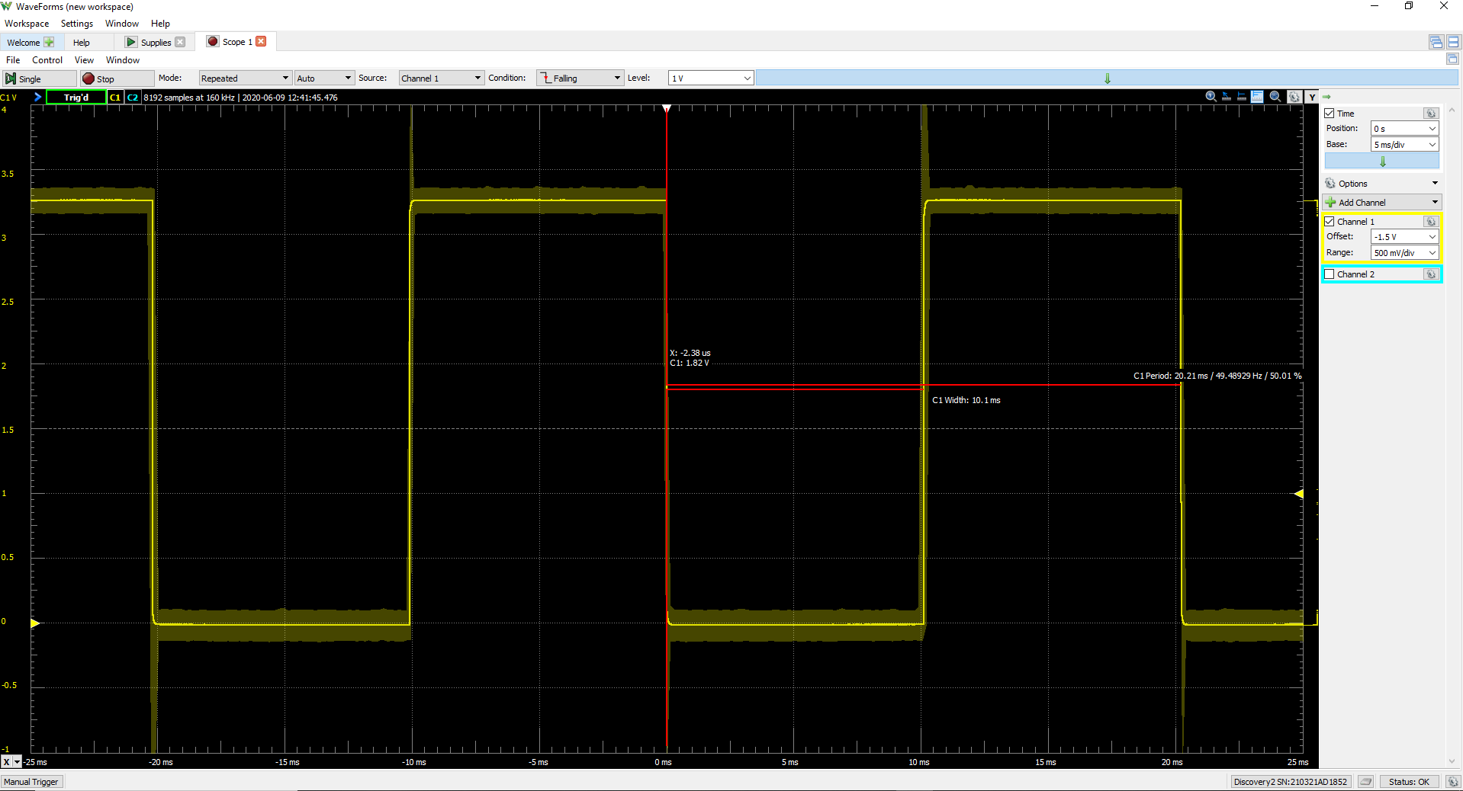

Figure 1: Section 2 DELAY_10MS  
C1 Width = 10.1ms  
Frequency = 49.48Hz

Note: In my code I reset my count 34 times. Mathematically resetting 33 times is closer to the amount of cycles I am supposed to count, however it was further from toggling every 10ms. When resetting 33 times I had a delay of 9.8ms, but when resetting 34 times I had a delay of 10.1ms

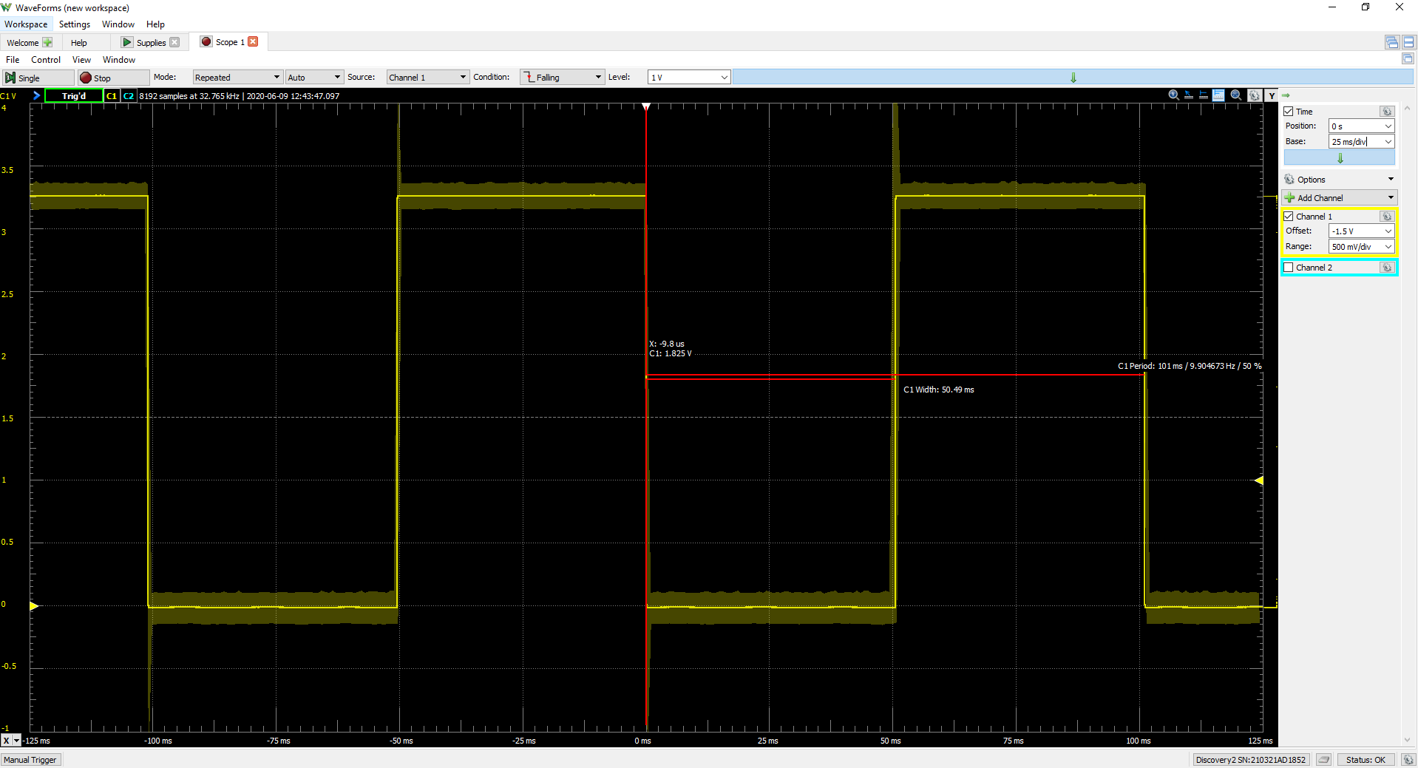

Figure 2: Section 2 DELAY_X_10MS where X = 5  
C1 Width = 50.49ms  
Frequency = 9.9Hz

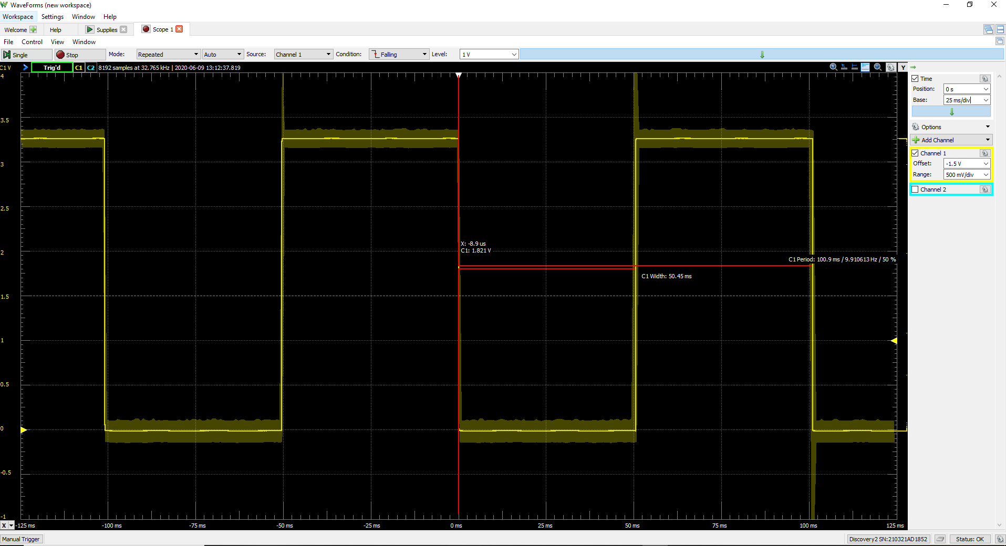

Figure 3: Section 2 Aiming for Frequency of 10Hz  
C1 Width = 50.45ms  
Frequency = 9.91Hz

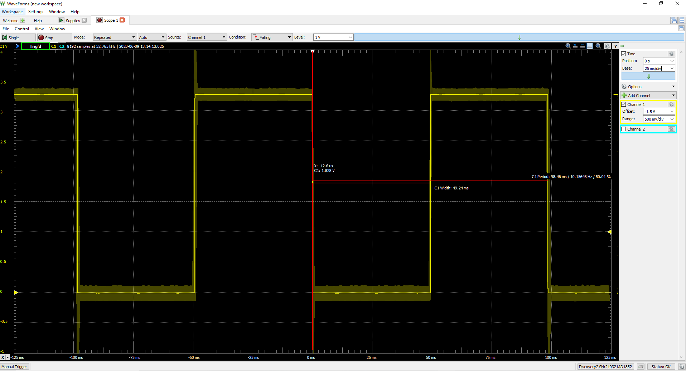

Figure 4: Section 3 Aiming for 50ms delay  
 Prescalar = 256  
Period = 3906  
C1 Width = 49.24ms  
Frequency = 10.15Hz

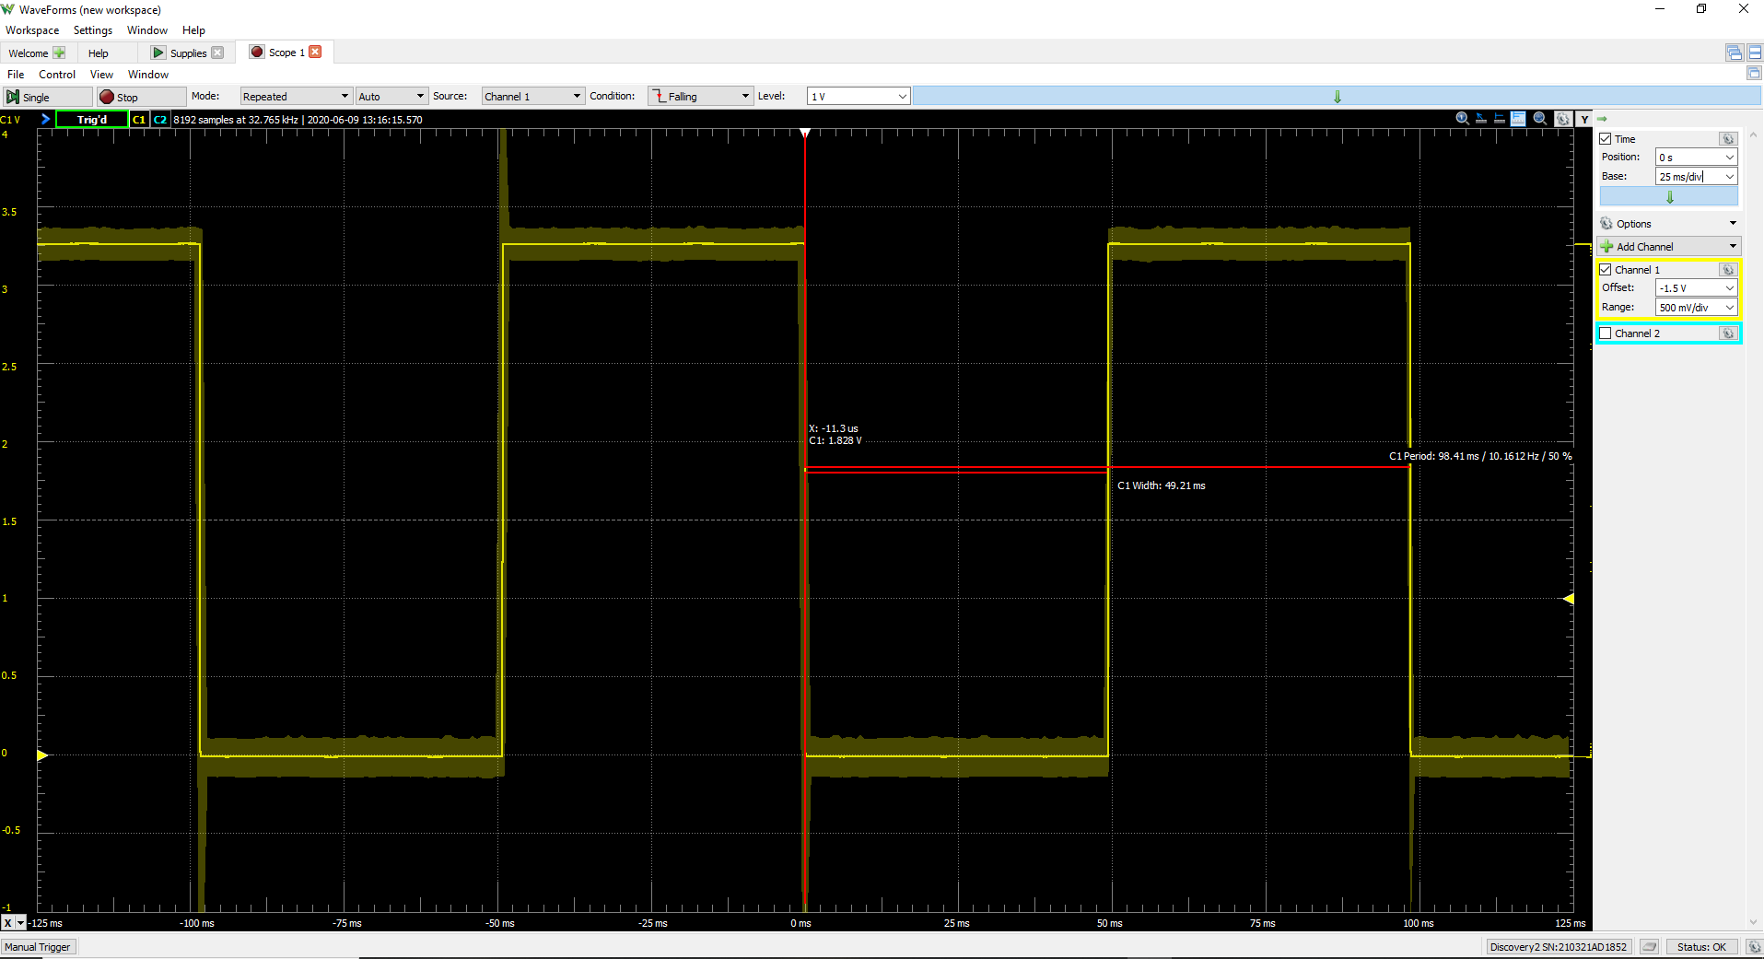

Figure 5: Section 3 Aiming for 50ms delay  
Prescalar = 2  
Period = 50,000  
C1 Width = 49.21ms  
Frequency = 10.16Hz

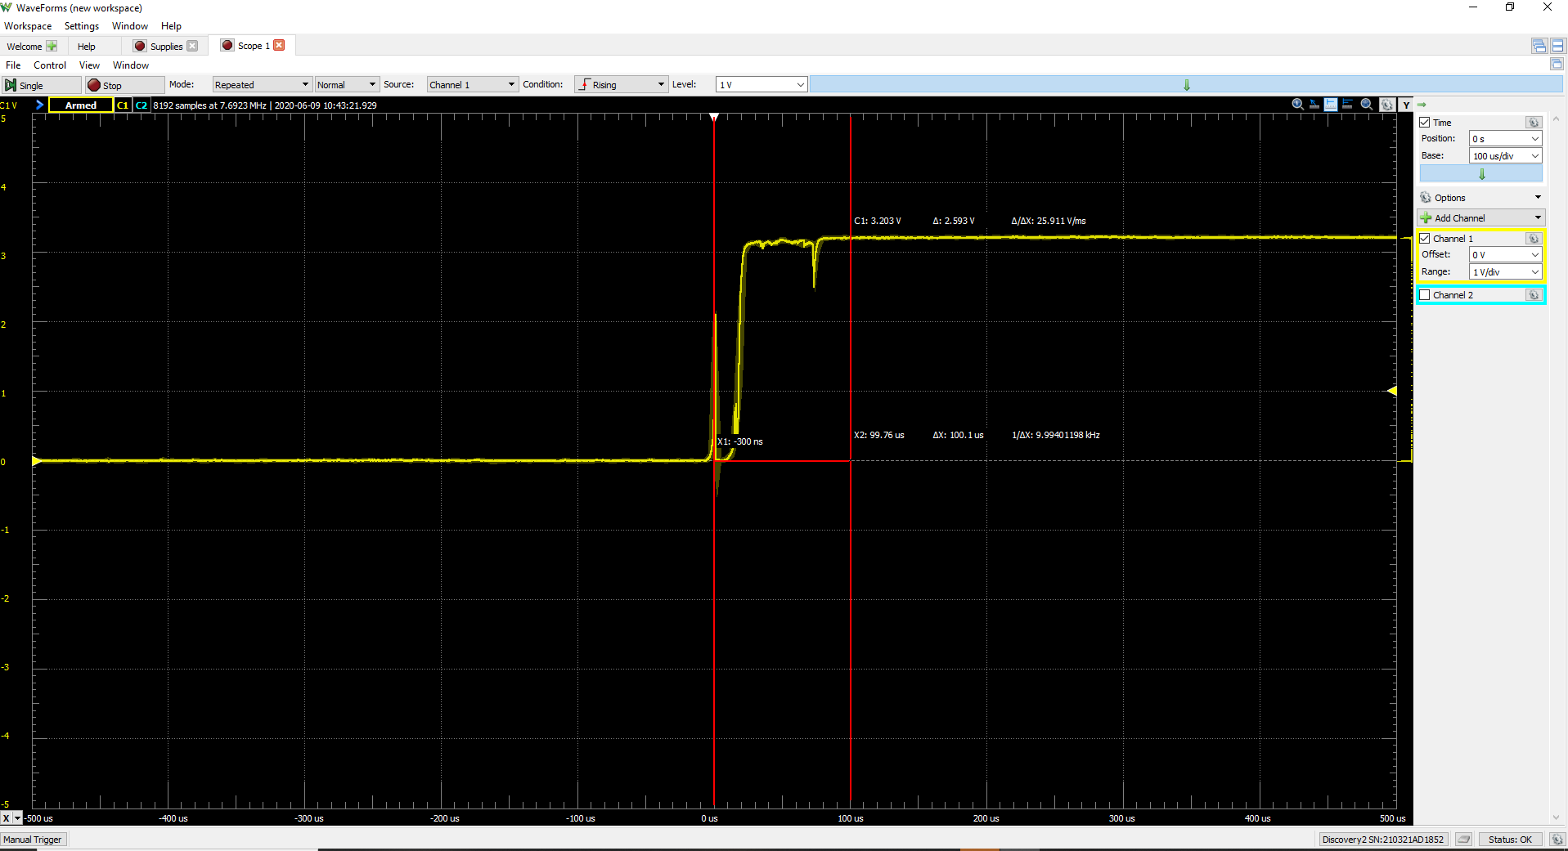

Figure 6: Section 4 Release Debouncing  
around 0.1ms

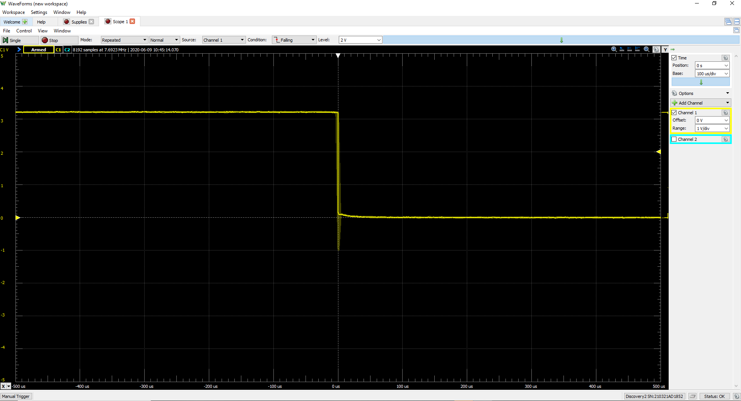

Figure 7: Section 4 Press Debouncing  
I could not really get a debounce while pressing the switch but here is a screenshot

**Figure 8 : Emulation Output**